**Bangladesh University of Business & Technology (BUBT)**

**Department of Computer Science and Engineering (CSE)**



Program : B.Sc. Engineering in CSE

Course Code : CSE 242

Course Title : Algorithms Lab

Course Credit : 1.5

Contact Hours : 3hrs

Semester : Summer 2019

Intake : 38th [Shift: Day]

Section : 01

**Sessional Primitives**

**Course Information**

**Course Name: CSE241- Algorithms**

**Credit Hours and Teaching Scheme:**

|  |  |  |  |
| --- | --- | --- | --- |
|  | Theory | Laboratory | Total |
| Credit Hours | 3 | 1.5 | 4.5 |
| Contact Hours | 3 Hours/Week for 13 Weeks + Final Exam in the 14th week | 3 Hours/Week for 13 Weeks | 6 Hours/Week for 13 Weeks +  Final Exam in the 14th week |
| Intake | 36 | Section | 02 |

**Prerequisites:** CSE 205 Data Structure

**Course Objectives**

The objective of the course is to teach techniques for effective problem solving in computing. The use of different paradigms of problem solving will be used to illustrate clever and efficient ways to solve a given problem. In each case emphasis will be placed on rigorously proving correctness of the algorithm. In addition, the analysis of the algorithm will be used to show the efficiency of the algorithm over the naive techniques.

**Course Synopsis**

Introduction: The Role of Algorithms in Computing, Growth of Functions, Divide and Conquer, Sorting and Order Statistics, Elementary Data Structures, Hash Tables, Binary Search Trees, Red-Black Trees, Advanced Design and Analysis Techniques, Dynamic Programming, Greedy Algorithms, Advanced Data Structures, Graph Algorithms, Minimum Spanning Tree, Single-Source Shortest Paths, All-Pairs Shortest Paths, NP-Completeness, Approximation Algorithms.

**Assessment**

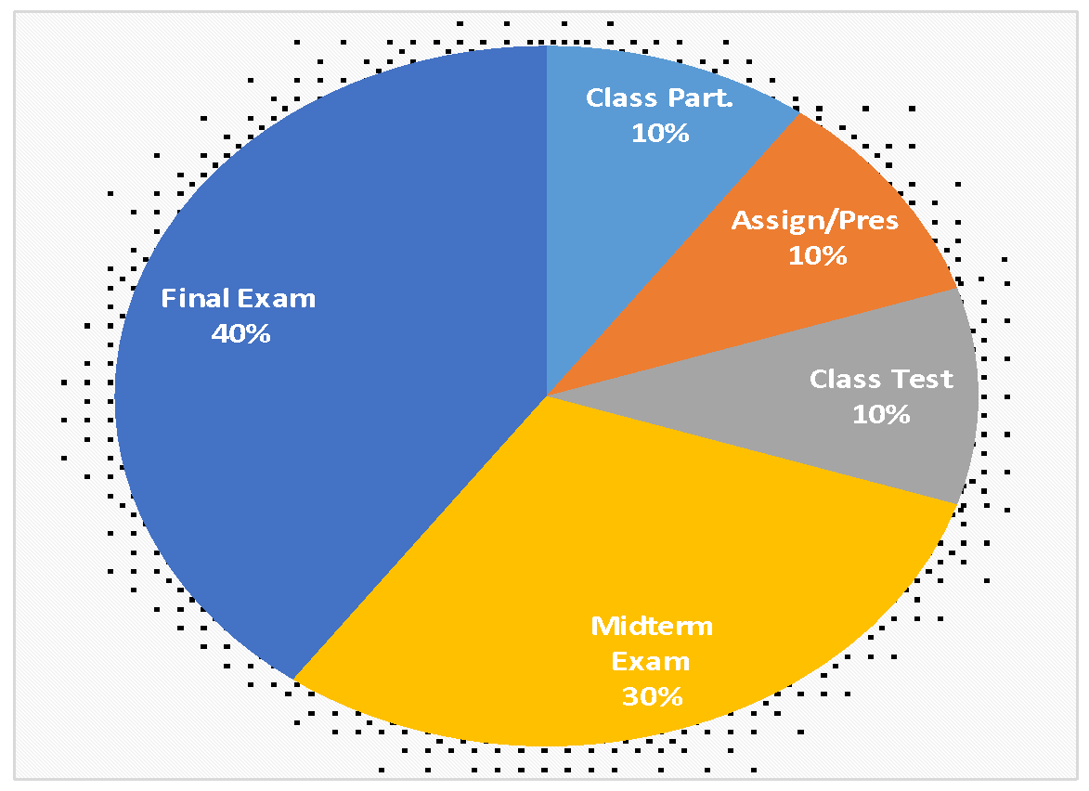

|  |  |  |
| --- | --- | --- |
| Class Participation | **:** | 10% |
| Assignment/Presentation | **:** | 10% |
| Class Test | **:** | 10% |
| Midterm Examination | **:** | 30% |
| Final Examination | **:** | 40% |

**Course Outcomes (COs)**

After completion of this course students will be able to:

|  |  |
| --- | --- |
| **CO1:** | **Understand** the relevance of algorithms for computational problems solving and **Analyze** the running time of the basic algorithms such as sorting, searching etc. |
| **CO2:** | **Explain** various techniques to solve recurrences. |
| **CO3:** | **Apply** the algorithms and design techniques to solve problems. |
| **CO4:** | **Analyze** the complexities of the given algorithms and Apply optimization techniques for improving the efficiency of algorithms. |

**Mapping of Course Outcomes (COs) to Program Outcomes (POs)**

|  |  |  |  |  |  |  |  |  |  |  |  |  |
| --- | --- | --- | --- | --- | --- | --- | --- | --- | --- | --- | --- | --- |
| CO | PO1 | PO2 | PO3 | PO4 | PO5 | PO6 | PO7 | PO8 | PO9 | PO10 | PO11 | PO12 |
| CO1 | √ |  |  |  |  |  |  |  |  |  |  |  |
| CO2 | √ |  |  |  |  |  |  |  |  |  |  |  |
| CO3 |  |  | √ |  |  |  |  |  |  |  |  |  |
| CO4 |  | √ |  |  |  |  |  |  |  |  |  |  |

|  |  |  |  |  |  |
| --- | --- | --- | --- | --- | --- |
| Sl. No. | COs | Corresponding POs | Bloom’s taxonomy domain/level | Delivery methods and activities | Assessment tools |
| 1 | **Understand** the relevance of algorithms for computational problems solving and **Analyze** the running time of the basic algorithms such as sorting, searching etc. | PO1 | Understand | Class Lecture and Discussion | Class Test, Quiz Test, Assignment, and Midterm |
| 2 | **Explain** various techniques to solve recurrences. | PO1 | Understand | Class Lecture and Discussion | Class Test, Quiz Test, Assignment, and Midterm |
| 3 | **Apply** the algorithms and design techniques to solve problems. | PO2, PO3 | Apply | Class Lecture and Discussion | Class Test, Quiz Test, Assignment, Midterm and Final |
| 4 | **Analyze** the complexities of the given algorithms and Apply optimization techniques for improving the efficiency of algorithms. | PO3, PO4 | Analyze | Class Lecture and Discussion | Class Test, Quiz Test, Assignment, and Final |

**Descriptions of Program Outcomes (POs)**

|  |  |
| --- | --- |
| PO1 | **Engineering Knowledge (Cognitive):** Apply the knowledge of mathematics, science, engineering fundamentals and an engineering specialization to the solution of complex engineering problems. |
| PO2 | **Problem Analysis (Cognitive):** Identify, formulate, research the literature and analyze complex engineering problems and reach substantiated conclusions using first principles of mathematics, the natural sciences and the engineering sciences. |
| PO3 | **Design/Development of Solutions (Cognitive, Affective):** Design solutions for complex engineering problems and design system components or processes that meet the specified needs with appropriate consideration for public health and safety as well as cultural, societal and environmental concerns. |
| PO4 | **Investigation (Cognitive, Psychomotor):** Conduct investigations of complex problems, considering design of experiments, analysis and interpretation of data and synthesis of information to provide valid conclusions. |
| PO5 | **Modern Tool Usage (Psychomotor, Cognitive):** Create, select and apply appropriate techniques, resources and modern engineering and IT tools including prediction and modeling to complex engineering activities with an understanding of the limitations. |
| PO6 | **The Engineer and Society (Affective):** Apply reasoning informed by contextual knowledge to assess societal, health, safety, legal and cultural issues and the consequent responsibilities relevant to professional engineering practice. |
| PO7 | **Environment and Sustainability (Affective, Cognitive):** Understand the impact of professional engineering solutions in societal and environmental contexts and demonstrate the knowledge of, and need for sustainable development. |
| PO8 | **Ethics (Affective):** Apply ethical principles and commit to professional ethics, responsibilities and the norms of the engineering practice. |
| PO9 | **Individual Work and Teamwork (Psychomotor, Affective):** Function effectively as an individual and as a member or leader of diverse teams as well as in multidisciplinary settings. |
| PO10 | **Communication (Psychomotor, Affective):** Communicate effectively about complex engineering activities with the engineering community and with society at large. Be able to comprehend and write effective reports, design documentation, make effective presentations and give and receive clear instructions. |
| PO11 | **Project Management and Finance (Cognitive, Psychomotor):** Demonstrate knowledge and understanding of the engineering and management principles and apply these to one’s own work as a member or a leader of a team to manage projects in multidisciplinary environments. |
| PO12 | **Life-Long Learning (Affective, Psychomotor):** Recognize the need for and have the preparation and ability to engage in independent, life-long learning in the broadest context of technological change. |

|  |  |  |  |  |  |  |
| --- | --- | --- | --- | --- | --- | --- |
| **Weekly Schedule**    **Teaching-Learning Method:**  Lecture, Class Discussion, Discussion Outside Class with Instructor | | | | | | |
| **Week** | **Lecture** | **Course Topics** | **Remarks** | **CO** | **Mark**  **of COs** | **Exam**  **(Mark)** |
|  |  |  |  |  |  |  |
| 1 | 1 | **Algorithm:** Definition, Application scopes,Pseudocode Convention | ( Thomas H. Cormen )  -  Ch-1 | **CO1** | **11** | **Mid-**  **Term**  **Exam**  **(30)** |
| 2 | **Insertion Sort:** Basics and analysis  **Selection Sort:** Basics and analysis | Ch-2 |
| 3 | **Growth of function**: Asymptotic notation, Standard notations and common functions. | Ch-3 | **CO2** |
| 2 | 4 | **Do** | “ |
| 5 | **Divide and Conquer:**  Merge sort basic and analysis. | Ch-4 | **CO1** | **08** |
| 6 | Strassen’s algorithm for matrix multiplication | **“** |
| 3 | 7 | **Heap:** Definition, property, maintenance | **“** |
| 8 | Heap sort algorithm | **“** |
| 9 | Quick sort basic and analysis | **“** |
| 4 | 10 | Sorting in linear time, counting sort, radix sort, bucket sort | “ |
| 11 | **Graph Algorithm:** BFS,DFS | Ch-5 |
| 12 | Recurrence technicalities, Maximum sub array problem | “ | **CO2** | **11** |
| 5 | 13 | Substitution method for solving recurrences | Ch-7 |
| 14 | Recurrence tree method for solving recurrences | Ch-8 |
| 15 | Master method for solving recurrences | Ch-22 |
| 6 | 16 | Do | “ |  |  |  |
| 17 | Review class for Mid-Term Examination |  |  |  |  |
| 7 | 18 | **Mid Term Examination** |  |  |  |  |
| 19 |
| 20 |
| 21 |
| 8 | 22 | **Greedy Algorithms**: Activity selection problem | Ch-16 | **CO3** | **20** | **Final**  **Exam**  **(40)** |
| 23 | Fractional Knapsack problem | “ |
| 24 | Huffman Coding | “ |
| 9 | 25 | Analysis of Greedy algorithms | “ | **CO4** |
| 26 | **Dynamic Programming**: Rod cutting | Ch-15 | **CO3** |
| 10 | 27 | Matrix Chain Multiplication | “ |
| 28 | Longest Common Subsequence | “ |
| 29 | 0/1 Knapsack | “ |
| 11 | 30 | Analysis of Dynamic Programming Alorithms | “ | **CO4** |
| 31 | **Minimum Spanning Trees:** Kruskal’s algorithm | Ch-23 | **CO3** | **20** |
| 32 | Prim’s algorithm | “ |
| 12 | 33 | Analysis of Minimum Spanning trees algorithms | “ | **CO4** |
| 34 | **Single Source Shortest Path**: Dijkstra’s Algorithm | Ch-24 | **CO3** |
| 35 | Bellman Ford Algorithm | “ |
| 36 | **All-Pairs Shortest Paths:** Floyd-Warshall algorithm | Ch-25 |
| 13 | 37 | Complexity Analysis of Shortest path algorithm | “ | CO4 |  |
| 38 | P, NP, NP hard, NP completeness | Ch-34 |  |
| 39 | **Troubleshooting Case Study, Review class for Semester Final Term** |  |  |  |  |
|  | | **Semester Final Examination** |  | | | |

**Descriptions of Cognitive Domain (Anderson and Krathwohl’s Taxonomy 2001):**

The **cognitive domain** involves the development of our mental skills and the acquisition of knowledge.

|  |  |  |  |
| --- | --- | --- | --- |
| **Level** | **Category** | **Meaning** | **Keywords** |
| C1 | Remembering | Recognizing or recalling knowledge from memory. Remembering is when memory is used to produce or retrieve definitions, facts, or lists, or to recite previously learned information. | Define, describe, draw, find, identify, label, list, match, name, quote, recall, recite, tell, write |
| C2 | Understanding | Constructing meaning from different types of functions be they written or graphic messages or activities like interpreting, exemplifying, classifying, summarizing, inferring, comparing, or explaining. | Classify, compare, exemplify, conclude, demonstrate, discuss, explain, identify, illustrate, interpret, paraphrase, predict, report |
| C3 | Applying | Carrying out or using a procedure through executing, or implementing. Applying relates to or refers to situations where learned material is used through products like models, presentations, interviews or simulations. | Apply, change, choose, compute, dramatize, implement, interview, prepare, produce, role play, select, show, transfer, use |
| C4 | Analyzing | Breaking materials or concepts into parts, determining how the parts relate to one another or how they interrelate, or how the parts relate to an overall structure or purpose. Mental actions included in this function are differentiating, organizing, and attributing, as well as being able to distinguish between the components or parts. When one is analyzing, he/she can illustrate this mental function by creating spreadsheets, surveys, charts, or diagrams, or graphic representations. | Analyze, characterize, classify, compare, contrast, debate, deconstruct, deduce, differentiate, discriminate, distinguish, examine, organize, outline, relate, research, separate, structure |
| C5 | Evaluating | Making judgments based on criteria and standards through checking and critiquing. Critiques, recommendations, and reports are some of the products that can be created to demonstrate the processes of evaluation. | Appraise, argue, assess, choose, conclude, critique, decide, evaluate, judge, justify, predict, prioritize, prove, rank, rate, select, monitor |
| C6 | Creating | Putting elements together to form a coherent or functional whole; reorganizing elements into a new pattern or structure through generating, planning, or producing. Creating requires users to put parts together in a new way, or synthesize parts into something new and different creating a new form or product. This process is the most difficult mental function. | Construct, design, develop, generate, hypothesize, invent, plan, produce, compose, create, make, perform, plan, produce |

**Teaching Materials/Equipment**

**Required References:** Introduction to Algorithms (5th Edition)

- Thomas H. Cormen, Charles E. Leiserson, Ronald L. Rivest, and Clifford Stein

**Recommended References:** The Algorithm Design Manual (4th Edition)

- Steven Skiena

- Hector Garcia-Molina, Jeffrey D. Ullman, Jennifer Widom

**Overall Assessment Scheme**

|  |  |  |  |  |  |
| --- | --- | --- | --- | --- | --- |
| **Assessment Area** | **CO** | | | | **Assessment Area Mark** |
|  | **CO1** | **CO2** | **CO3** | **CO4** |  |
| Class Participation | 2.5 | 2.5 | 2.5 | 2.5 | 10 |
| Assignment/Presentation | 2.5 | 2.5 | 2.5 | 2.5 | 10 |
| Class Test | 2.5 | 2.5 | 2.5 | 2.5 | 10 |
| Midterm Exam | 15 | 15 |  |  | 30 |
| Final Exam |  |  | 25 | 15 | 40 |
| **Total Mark** | **22.5** | **22.5** | **32.5** | **22.5** | **100** |

**Grading System**

|  |  |  |  |
| --- | --- | --- | --- |
| **Numerical Grade** | **Letter Grade** | | **Grade Point** |
| 80% and above | A+ | (A Plus) | 4.00 |
| 75% to less than 80% | A | (A Regular) | 3.75 |
| 70% to less than 75% | A- | (A Minus) | 3.50 |
| 65% to less than 70% | B+ | (B Plus) | 3.25 |
| 60% to less than 65% | B | (B Regular) | 3.00 |
| 55% to less than 60% | B- | (B Minus) | 2.75 |
| 50% to less than 55% | C+ | (C Plus) | 2.50 |
| 45% to less than 50% | C | (C Regular) | 2.25 |
| 40% to less than 45% | D |  | 2.00 |
| Less than 40% | F |  | 0.00 |

**Instructor Information**

|  |  |
| --- | --- |
| **Instructor :** | **Dr. M Firoz Mridha**  Associate Professor,  Department of Computer Science & Engineering |
| **Office :** | Room No-603 |
| **Phone :** | +8801674791594 |
| **Email :** | firoz@bubt.edu.bd |

|  |  |  |
| --- | --- | --- |
| **Day** | **Time** | **Room No** |
| Sunday | 11:45 AM – 12:45 PM | 320 |
| Monday | 09:35AM – 10:35AM | 320 |
| Wednesday | 09:35AM – 10:35AM | 320 |

**Class Schedule**

**Office Hour**

|  |  |  |  |  |  |  |  |  |  |  |  |
| --- | --- | --- | --- | --- | --- | --- | --- | --- | --- | --- | --- |
| **DAYS** | **8:30-09:30** | **09:35-10:35** | **10:40-11:40** | **11:45-12:45** | **12:45- 01:15** | **01:15-02:15** | **02:20-03:20** | **03:25-04:25** | **04.30-05:30** | **06.00-07:30** | **07:45-09:15** |
| **SAT** | **DAY OFF** | | | | | | | | | | |
| **SUN** | CSE 352 | CSE 352 | CSE 352 | CSE 241 | **Office**  **Hour** | **Office**  **Hour** | **Office**  **Hour** |  |  |  |  |
| **MON** | **Office**  **Hour** | CSE 241 | CSE 351 | **Office**  **Hour** | **Office**  **Hour** | **Office**  **Hour** | **Office**  **Hour** |  |  |  |  |
| **TUE** | CSE 242 | CSE 242 | CSE 242 | CSE 351 | **Office**  **Hour** | **Office**  **Hour** | **Office**  **Hour** |  |  |  |  |
| **WED** | CSE 351 | CSE 241 | **Office**  **Hour** | **Office**  **Hour** | **Office**  **Hour** | **Office**  **Hour** | **Office**  **Hour** |  |  |  |  |
| **FRI** |  |  |  |  |  |  |  |  |  | 6:00-7:30PM  CSE 313 | 7:30-9:00PM  CSE 313 |

**Special Instructions**

* Students are expected to attend all classes and examinations. A student MUST have at least

70% class attendance to sit for the final exam.

* Students will not be allowed to enter into the classroom after 20 minutes of the starting time.
* For plagiarism, the grade will automatically become zero for that exam/assignment.
* All mobile phones MUST be turned to silent mode during class and exam period.
* There is zero tolerance for cheating in exam. The only penalty for cheating is expulsion

for several semesters as decided by the Disciplinary Committee of the university.

**Prepared by: Checked by: Approved by:**